### Using Bluetooth APP

**For Android system:**

1. Click the Frog_Otto compression package to direct install the Frog_Otto APP; installed well, appear the icon below on your mobile phone:

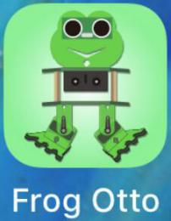

Download the Frog_Otto package from the link below:

<https://fs.keyestudio.com/KS0446-APP>

Or you can download the keyestudio Frog_Otto APP direct from the Google Play:

<https://play.google.com/store/apps/details?id=com.keyestudio.frogotto>

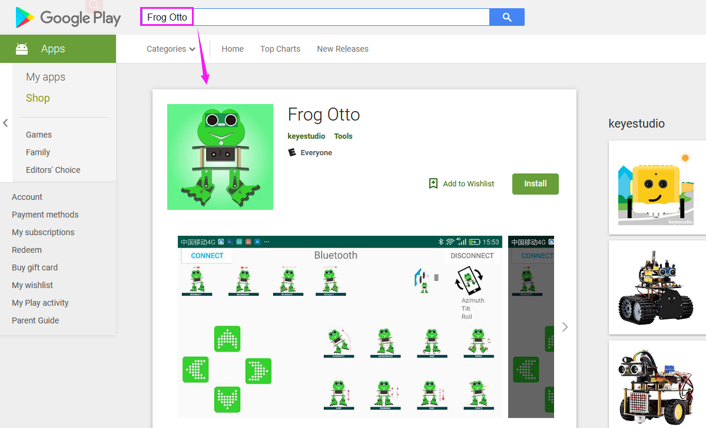

1. Tap the Frog_Otto icon to enter the Bluetooth APP. As shown below.

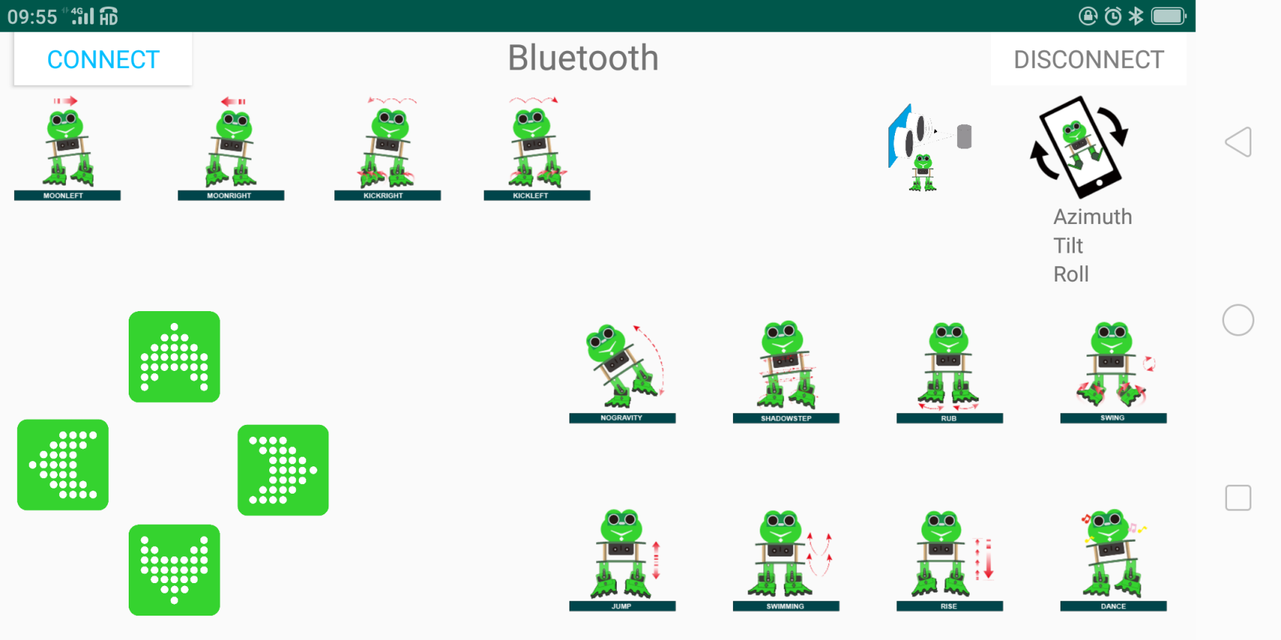

1. Done uploading the code to control board, connect the Bluetooth module, the LED on the Bluetooth module will flash.   
   Then tap the option CONNECT on the APP, searching the Bluetooth.

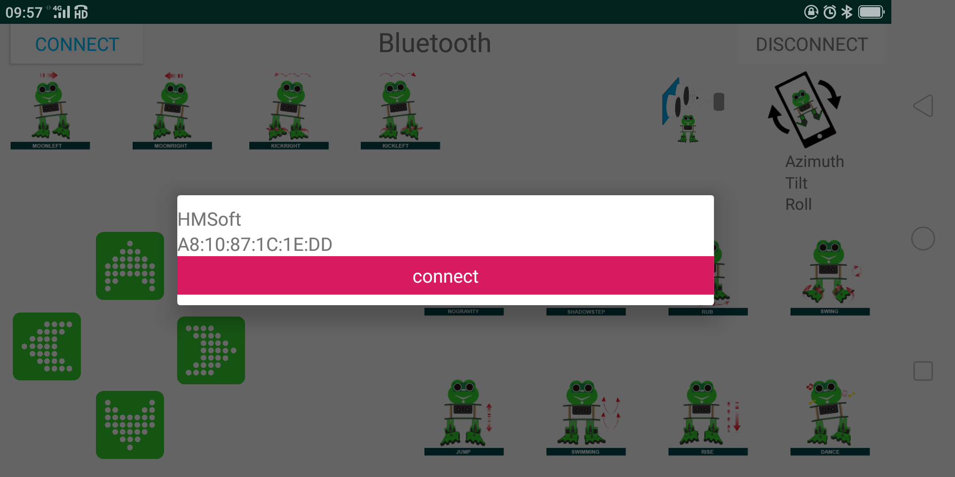

1. Click to connect the Bluetooth. HMSoft connected, Bluetooth LED will turn on normally.

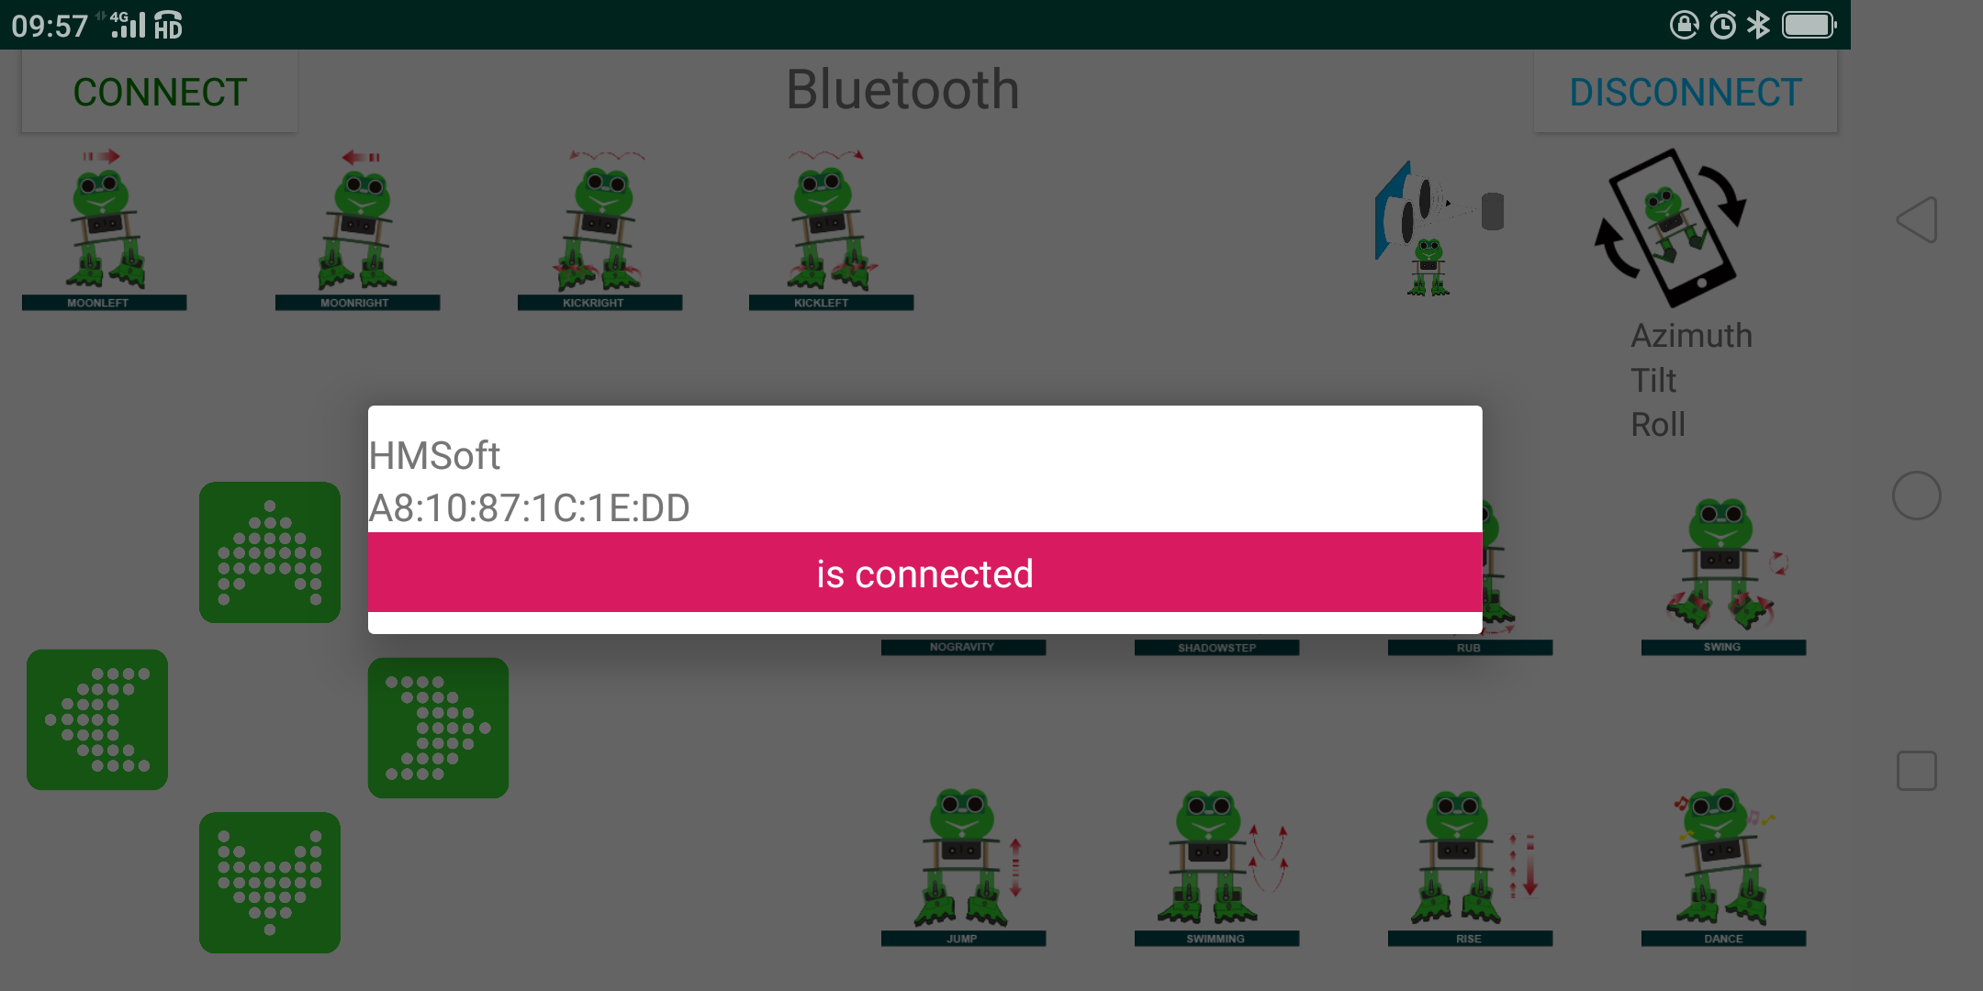

**The Bluetooth APP interface is shown below:**



|  |  |  |
| --- | --- | --- |
| **Button** | **Function** | |
|  | pair and connect HM-10 Bluetooth module | |
|  | enter Bluetooth control interface | |
|  | disconnect the Bluetooth | |
|  | **Control character** | **Function** |
| Press: F  Release: S | Press the button, robot goes front; release to stop |
|  | Press: B  Release: S | Press the button, robot goes back; release to stop |
|  | Press: L  Release: S | Press the button, robot turns left; release to stop |
|  | Press: R  Release: S | Press the button, robot turns right; release to stop |
|  | Press: 1  Release: S | Press to wander left; release to stop |
|  | Press: 2  Release: S | Press to wander right; release to stop |
|  | Press: 3  Release: S | Press to kick right; release to stop |
|  | Press: 4  Release: S | Press to kick left; release to stop |
|  | Press: 6  Release: S | Tap to tilt right, then slowly turn back |
|  | Press: 7  Release: S | Tap for SHADOWSTEP |
|  | Press: 8  Release: S | Press to rub; release to stop |
|  | Press: G  Release: S | Press to swing left and right |
|  | Press: 9  Release: S | Press to jump; release to stop |
|  | Press: H  Release: S | Press to start swimming motion; release to stop |
|  | Press: J  Release: S | Tap to slowly pick up feet and put it down |
|  | Press: P  Release: S | Tap to dance |
|  | Tap once to send: U  Tap again to send: S | Start ultrasonic avoiding function |
|  | / | Tap once to start the mobile gesture control; tap again to close |